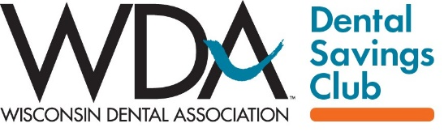

NEWSLETTER OR WEBSITE COPY

Short option – for website or social media

NAME OF DENTAL OFFICE is proud to be a provider for the WDA Dental Savings Club, a new way for Wisconsin residents to obtain affordable, transparent and convenient dental care. The Club is a program of the Wisconsin Dental Association, which has been protecting the Badger State’s oral health for over 150 years. Learn more at WDAclub.com.

Longer option – for newsletters

NAME OF DENTAL OFFICE is proud to be a provider for the WDA Dental Savings Club, a new way for Wisconsin residents to obtain affordable, transparent and convenient dental care. The Club is a program of the Wisconsin Dental Association, which has been protecting the Badger State’s oral health for over 150 years.

Club membership is a great option for those without dental insurance or whose oral health needs exceed their yearly benefits. Club members pay a small annual fee ($48/individual and $108/family) to receive savings of up to 55% at participating dental offices statewide. There are no yearly maximums on care and savings, and no reimbursement forms or paperwork. Everything – from finding a dentist, requesting the appointment and paying the bill – is done via an easy-to-use mobile app. Patients who qualify for NAME OF DENTAL OFFICE’S in-house payment plan can use it with their savings, too.

Research shows that 90% of Americans recognize the connection between good oral health and good overall health. Yet, only 50% see a dentist regularly, with cost frequently cited as the reason to forgo dental care. We want you to be healthy. If you think the WDA Dental Savings Club might be an option for you, visit www.WDAclub.com for more information and to join.

